CSA1596-CLOUDCOMPUTING

ANDBIGDATAANALYTICSFORAUDIT MONITORING

**DAY-01**

NAME:P.Padmakar

REG.NO:192125041

1. CABBOOKING:
2. COURSEENROLLEMNT:
3. FLIGHT RESERVATIONS:4.PURCHASEORDER:

5.HOTELROOMMANAGEMENT:

# CABBOOKING

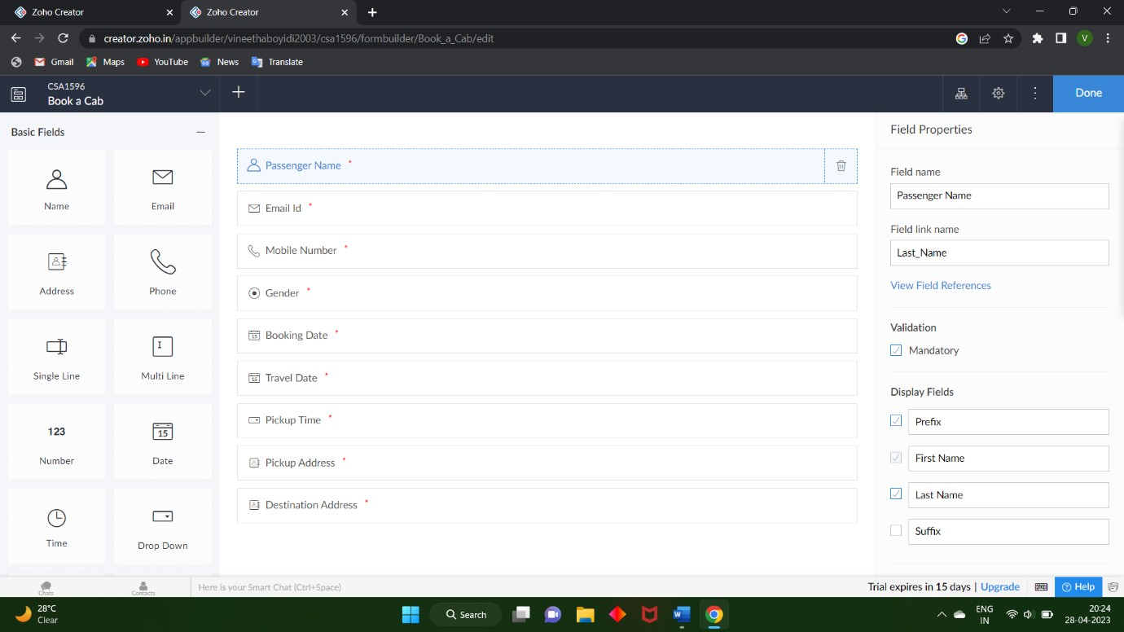

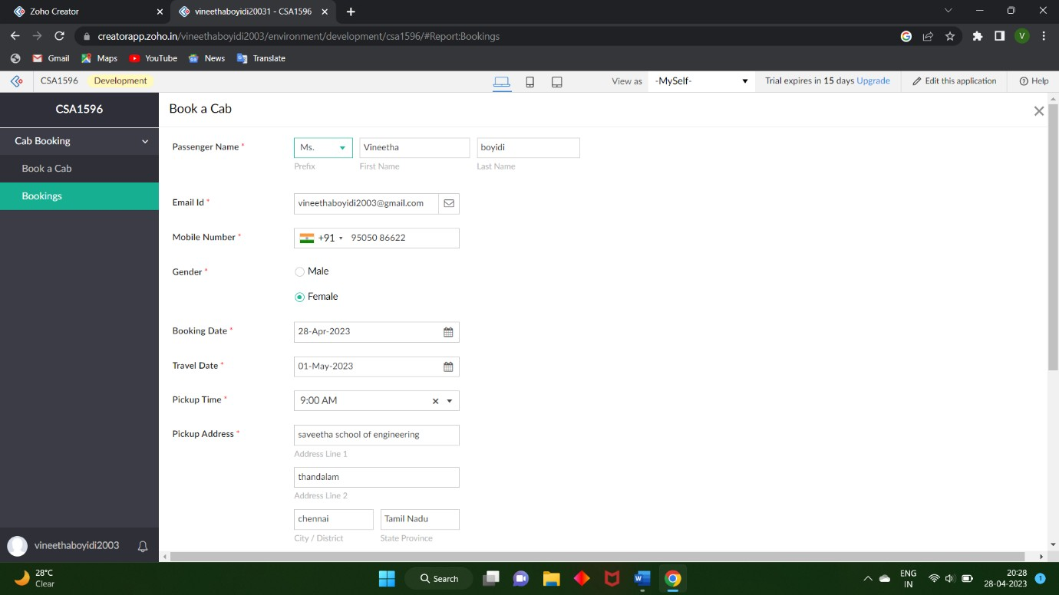

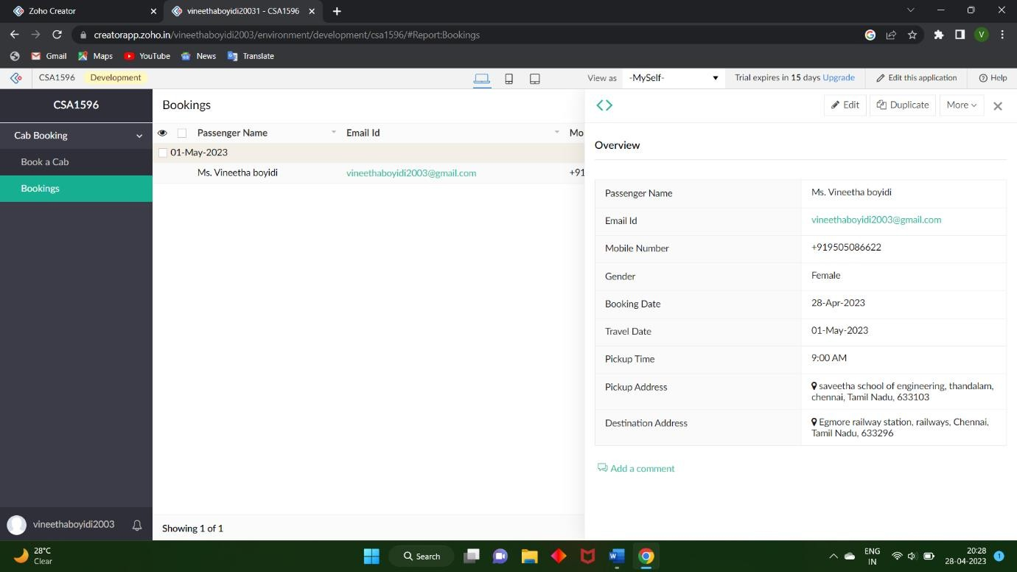

1. ***COURSEENROLLMENT***

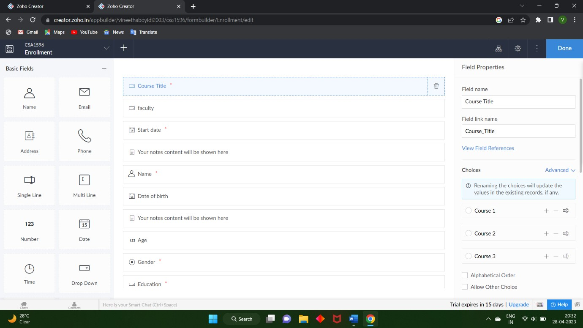

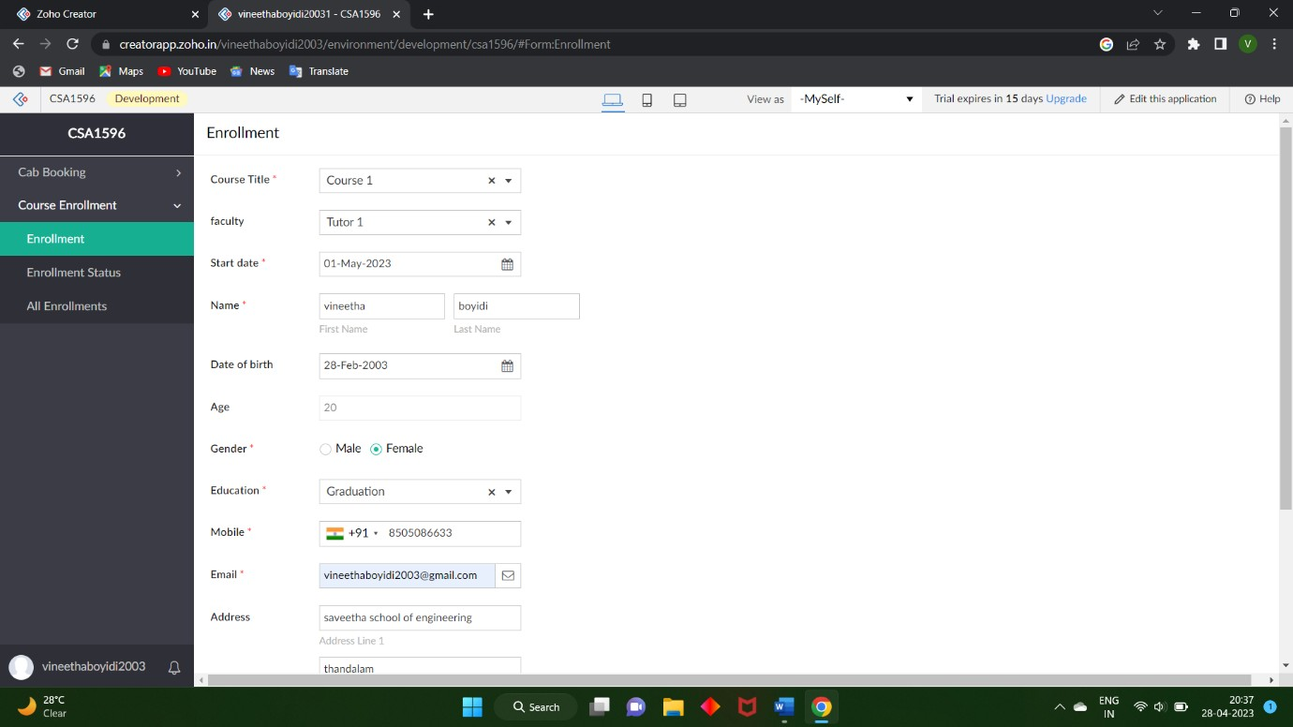

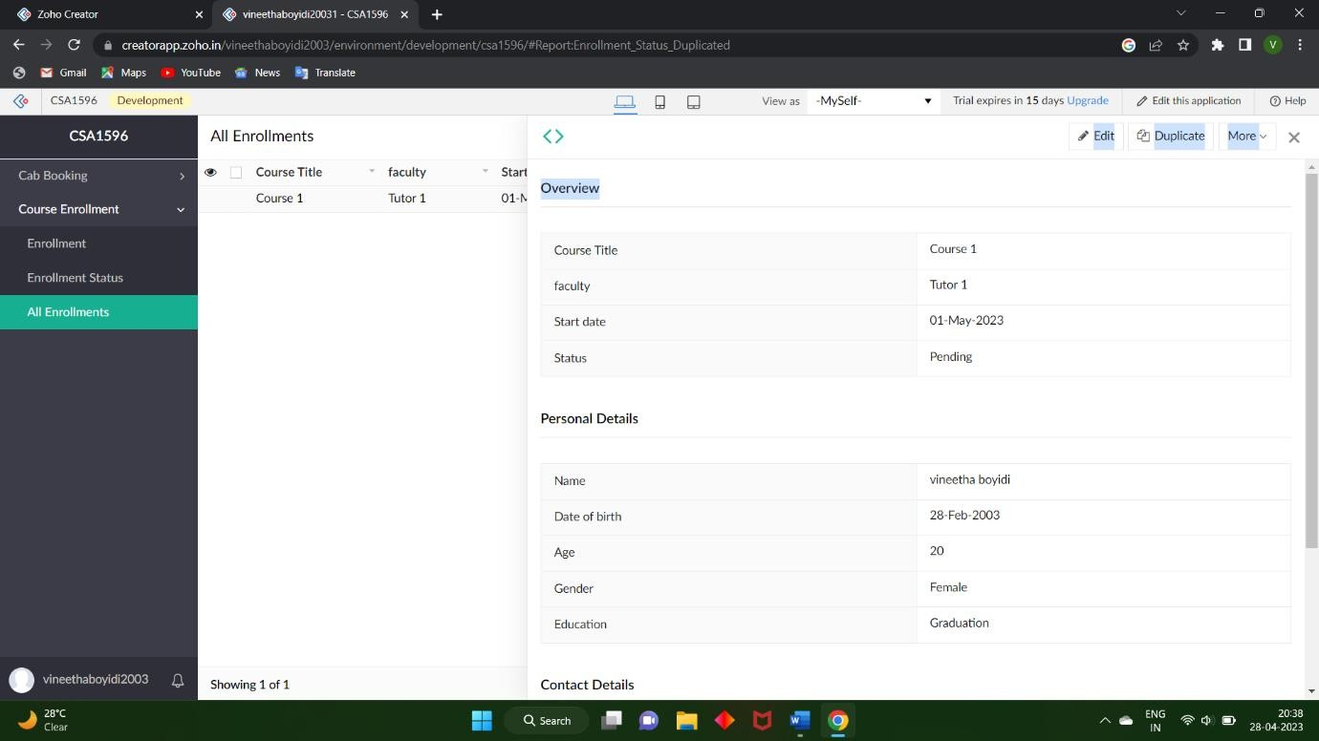

# FLIGHTRESERVATIONS

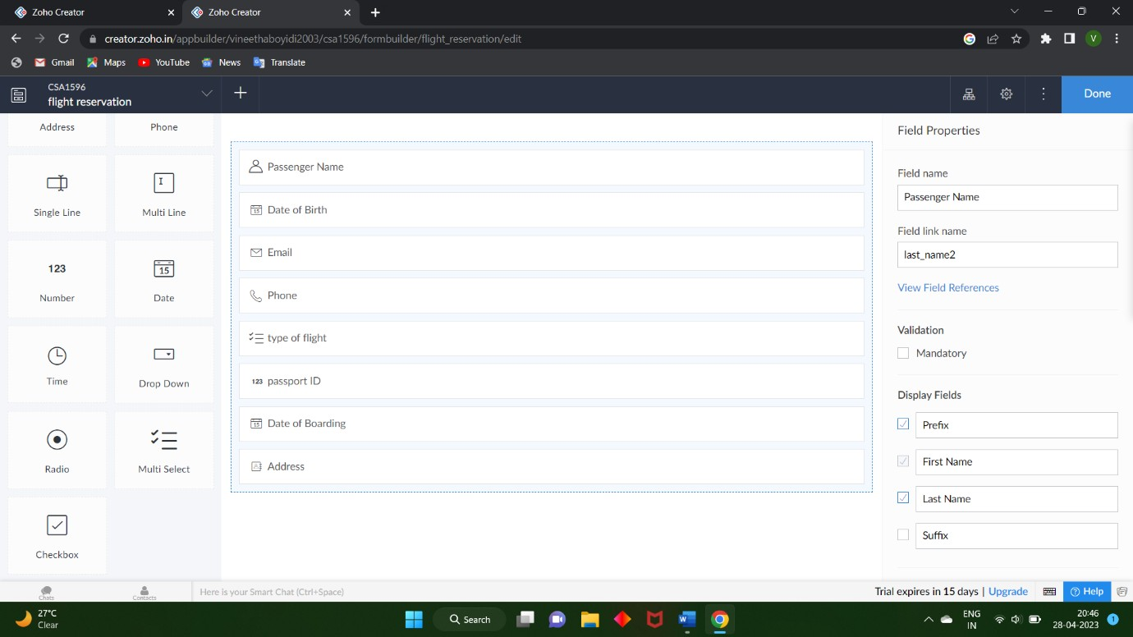

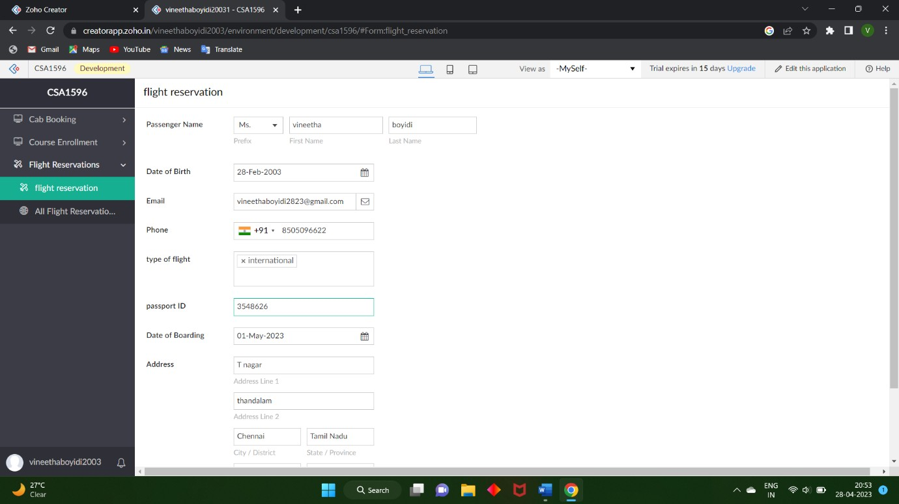

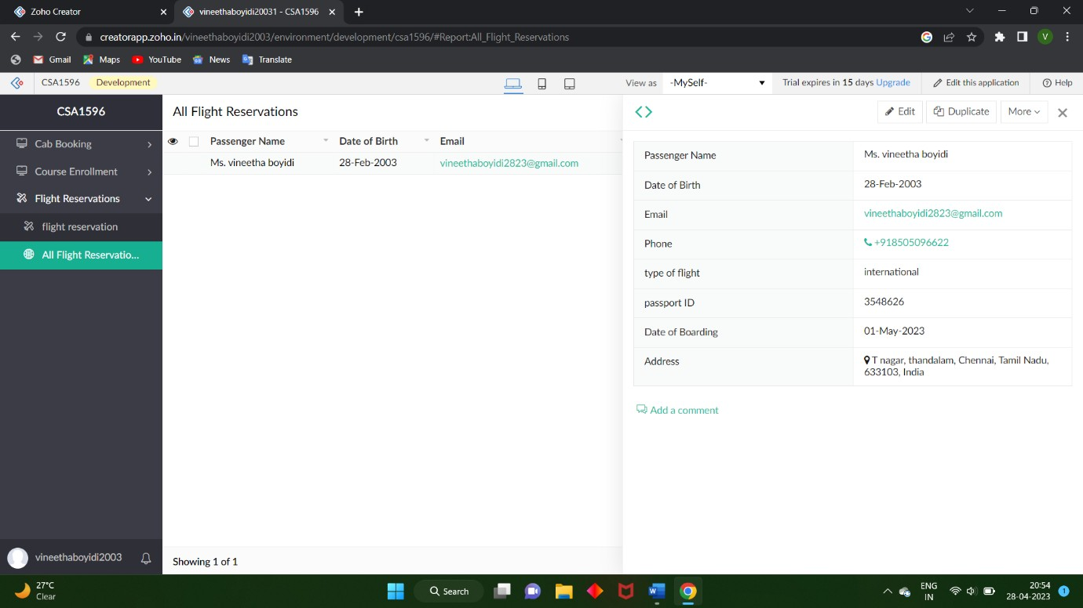

1. ***PURCHASEORDER***

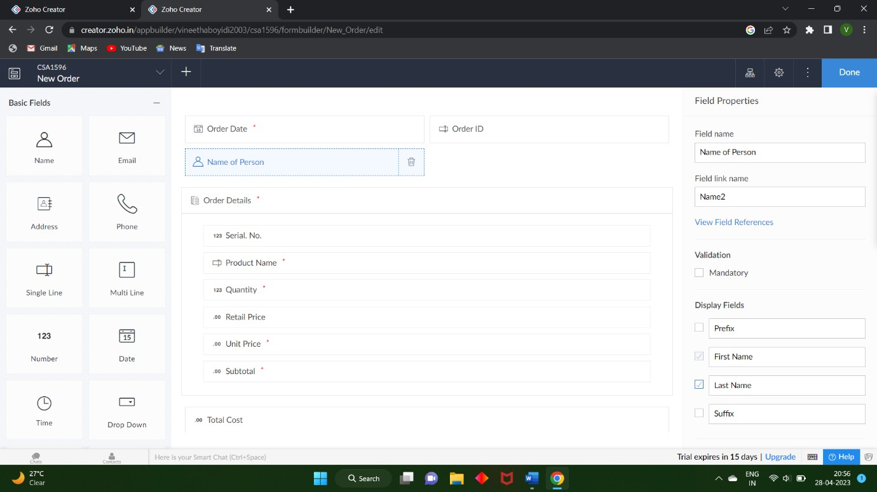

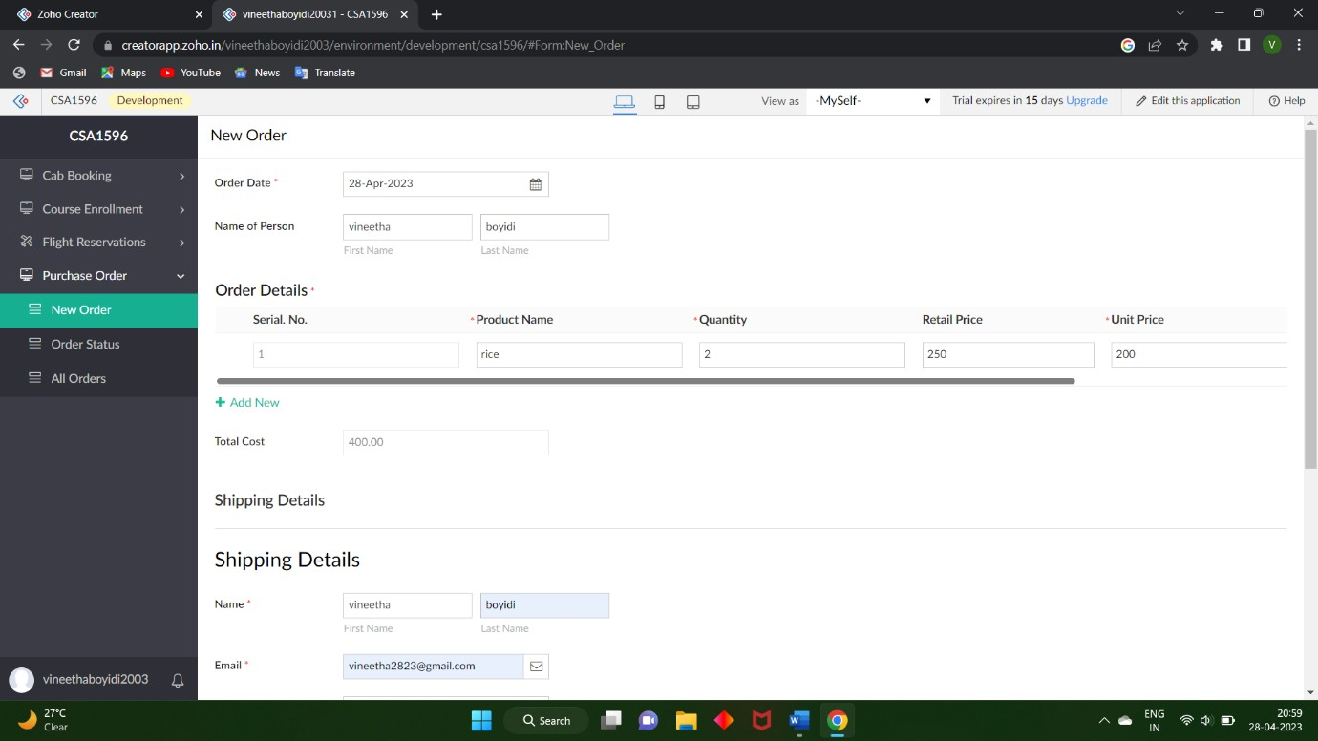

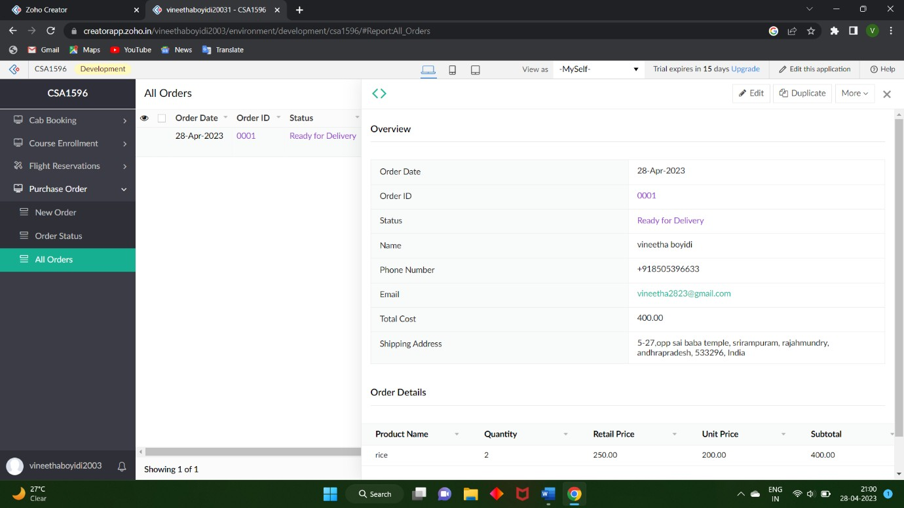

# HOTELROOMMANAGEMENT

